## Report 3, deadline see Canvas

## Target analysis of PCP (1 points)

As explained during the lecture, see also compartment_models.pdf and 20111124PCP.pdf

Write a caption of ≈5 lines below a screenshot of the target analysis results. Add a screenshot of the full Kmatrix window.

## Cyanobacterial phycobilisome core antenna CK

(3 points) Start with an Empty Project, call it **CK global**, and perform a global analysis using **two** components of emission data **CKtr4U.ascii** that were measured using a streak camera after 590 nm excitation**.**

Use a weight of 0.3 for the data above 750 nm. Dispersion can be modelled with a second order polynomial, center wavelength 692 nm, coefficients 2.71 and −2.85.

Interpret the EAS and DAS. Write a caption of ≈5 lines below a screenshot of the global analysis results.

(4 points) CK contains 72 allophycocyanin pigments in total. These can be divided in two types of pigments, APCa (66) and APCb (6). Perform a target analysis as sketched below.

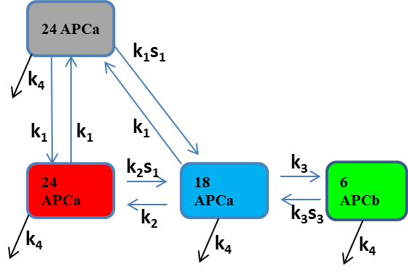

Fix , ,  and . Assume that the input for each compartment is proportional to the number of pigments it contains, i.e. ,  and . Estimate the unknown rate constants  and write those estimates (and their estimated standard errors) in this report.

Fill the following table:

|  |  |
| --- | --- |
| Species | Emission maximum (nm) |
| APCa |  |
| APCb |  |

Interpret the SAS. Write a caption of ≈5 lines below a screenshot of the target analysis results. Add a screenshot of the full Kmatrix window.

(2 points) Answer the following question:

In the fully equilibrated excited state, what are the relative populations of APCa and APCb pigments at 1000 ps? How can this ratio be explained? Compute the entropy and the enthalpy difference between the APCa (66) and APCb (6) pigments, use .